Testing Detail Document

Refer below for the testing screenshots for processing an email PDF file and get the request type and sub request type along with confidence score by reading the context in the email.

Below is the web user interface we have built for this project.

**Step 1:** Web User Interface

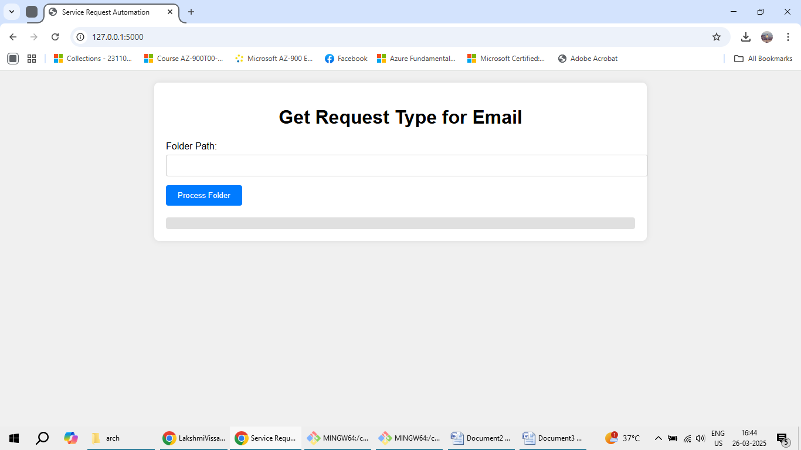

**Step 2:** Place all emails in a folder

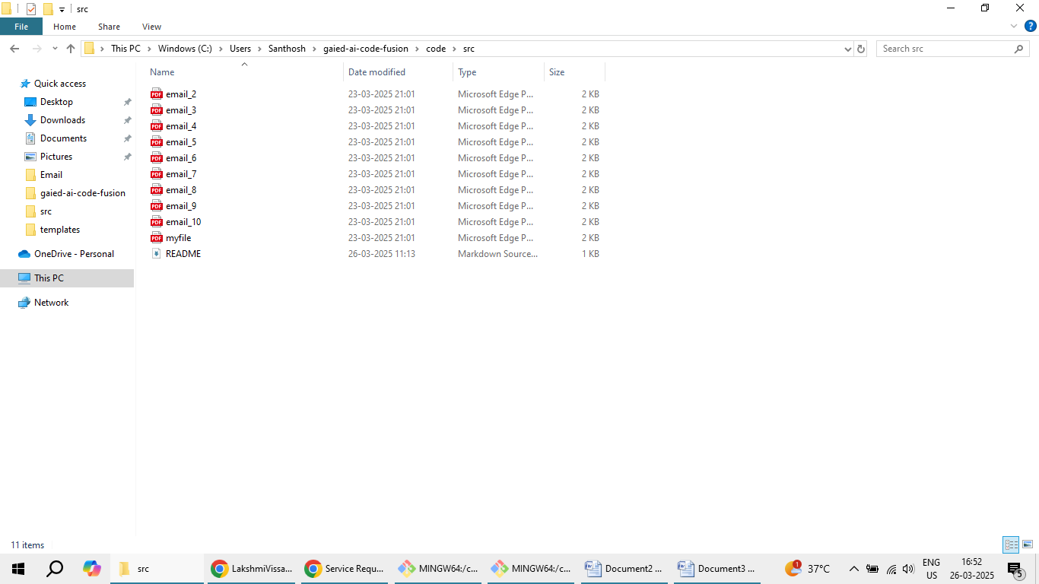

**Sample Email:**

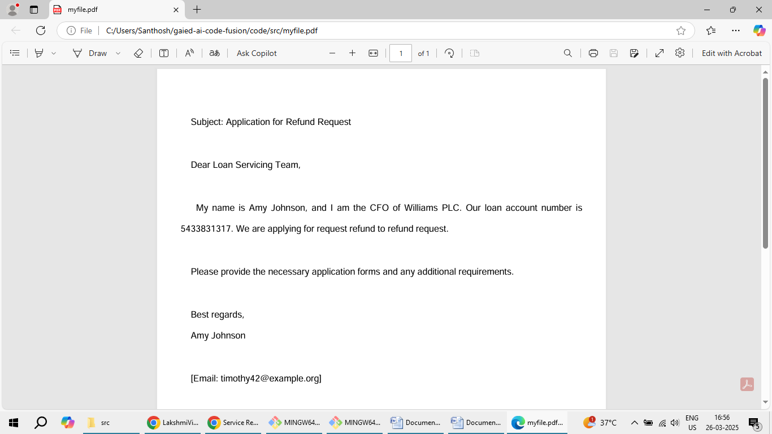

**Step 3:** Provide PDF path details in Web UI and click on Process Folder

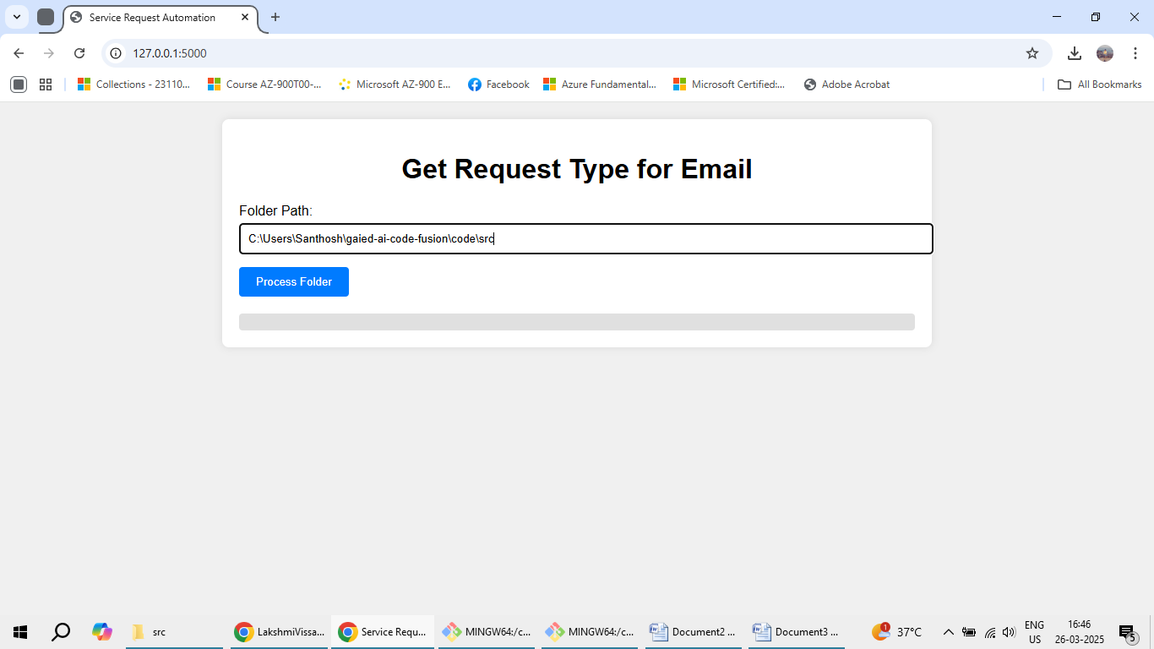

**Step 4**: Displays Output in JSON Format as below.

